**Ideation Phase**

**Brainstorm & Idea Prioritization Template**

|  |  |
| --- | --- |
| Date | 27 June 2025 |
| Team ID | LTVIP2025TMID31456 |
| Project Name | Health ai: Intelligent healthcare assistant using IBM Granite |
| Maximum Marks | 4 Marks |

**Brainstorm & Idea Prioritization Template:**

User-centered features such as symptom checker, medication reminders, and personalized health tips should be prioritized .Seamless natural language understanding and conversational ability using IBM Granite's advanced language models.Real-time, context-aware response generation for medical queries with reliable accuracy.Integration with electronic health records (EHR) and wearables to provide holistic health insights

Data privacy and HIPAA/GDPR compliance mechanisms to ensure user trust and security.Multilingual and voice interface support to cater to diverse users and accessibility needs.Emergency response and escalation protocols for critical symptoms or high-risk scenarios

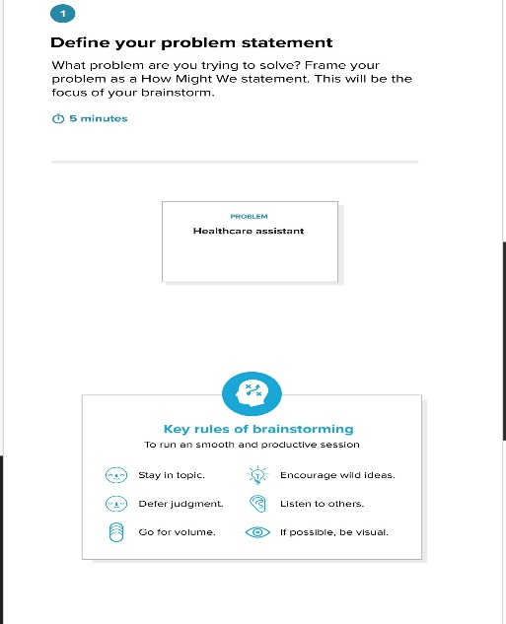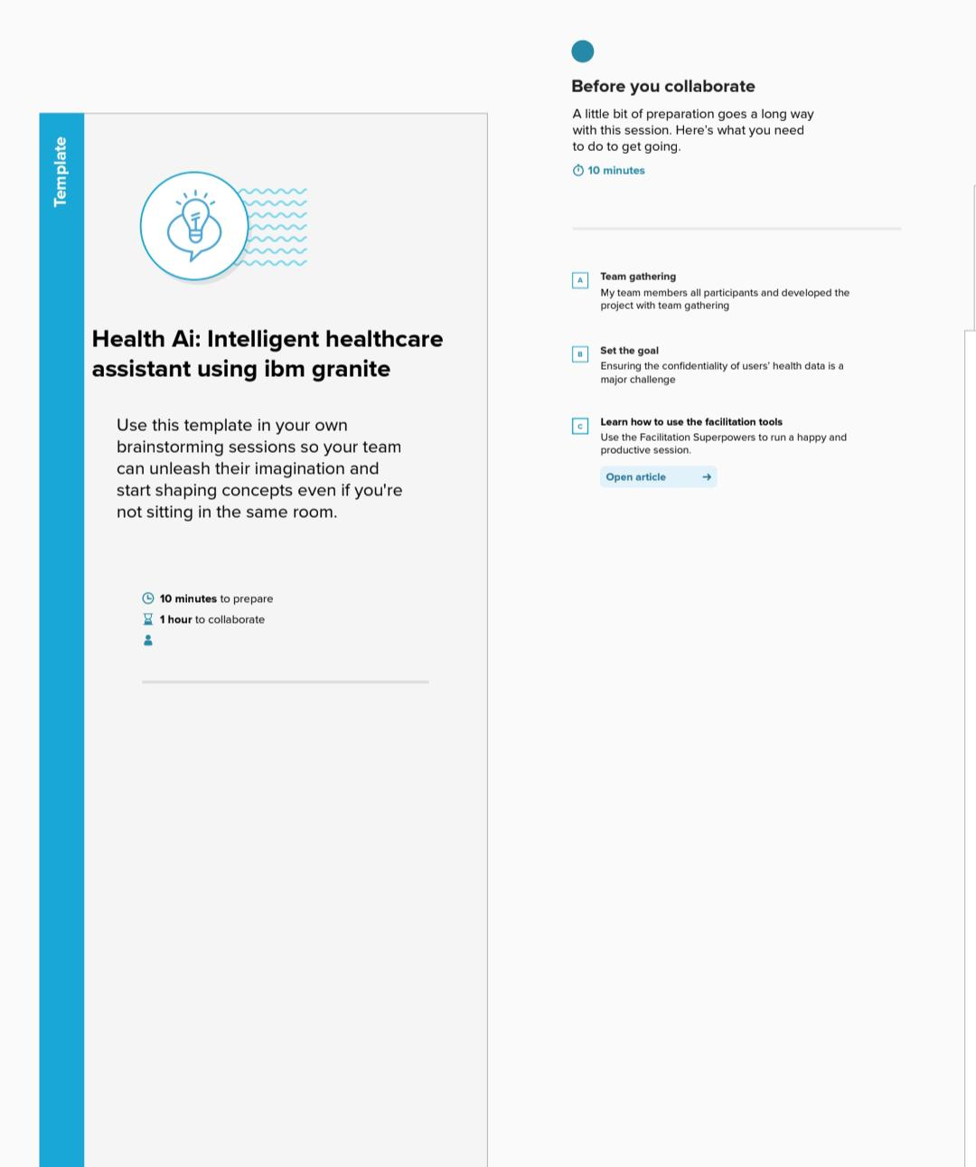**Step-1: Team Gathering, Collaboration and Select the Problem Statement**

**Step-2: Brainstorm, Idea Listing and Grouping**

**Step-3: Idea Prioritization**

